**[Articulation Point](https://practice.geeksforgeeks.org/problems/articulation-point-1/1)**

Given an undirected connected graph with **V**vertices and adjacency list **adj**. You are required to find all the vertices removing which (and edges through it) disconnects the graph into 2 or more components.  
**Note:**Indexing is zero-based i.e nodes numbering from (0 to V-1). There might be loops present in the graph.

**Example 1:**

**Input:**

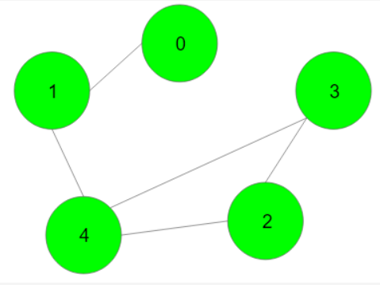

**Output:**{1,4}

**Explanation:** Removing the vertex 1 will

disconnect the graph as-

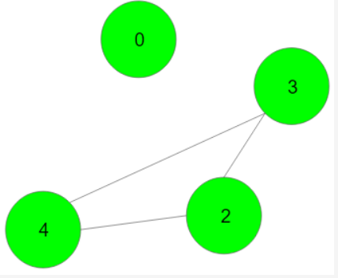

Removing the vertex 4 will disconnect the

Graph as

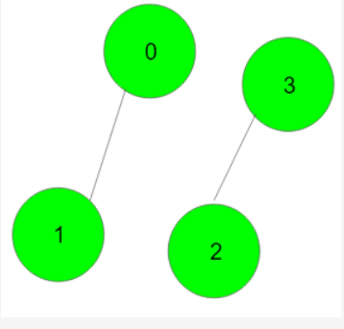

**Your Task:**  
You don't need to read or print anything. Your task is to complete the function **articulationPoints()**which takes V and adj as input parameters and returns a list containing all the vertices removing which turn the graph into two or more disconnected components in sorted order. If there are no such vertices then returns a list containing -1.

**Expected Time Complexity:**O(V + E)  
**Expected Auxiliary Space:**O(V)

**Constraints:**  
1 ≤ V ≤ 105